1. What is a honey bee?
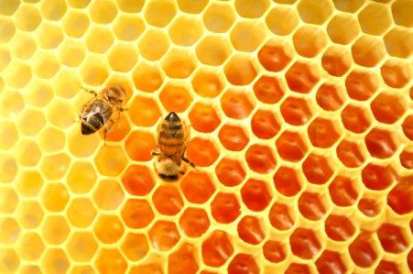
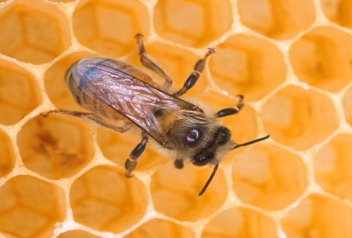

- Honey bees are gentle creatures.
- Honey bees live hives where there are lots of hexagon shaped cells to make honey.
- Honey bees very rarely sting for if they do they die straight after.
- Honey bees are too busy to worry about people.

2. What does a honey bee look like?
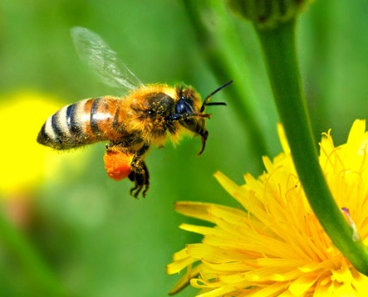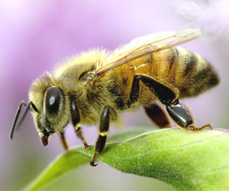
- Honey bees are brownish orange and black.
- They have pollen baskets on their legs to collect and carry pollen from flowers back to their hives.
- Bees have 5 eyes, 6 legs and 4 wings.
- They do not have any ears, nose, mouth or hands.

3. Where do honey bees live?
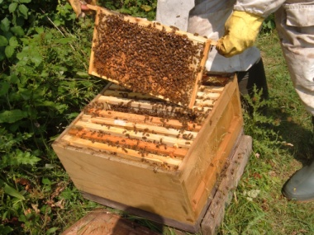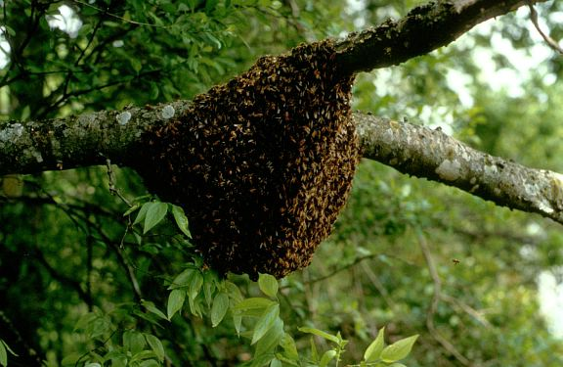
- Honey bees live in a bee hive.
- A hive can have up to 80,000 bees.
- Most of the bees are female worker bees.
- Less than 1000 are male drone bees.

4. What is a queen bee?
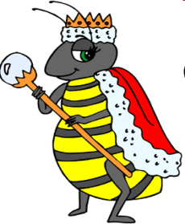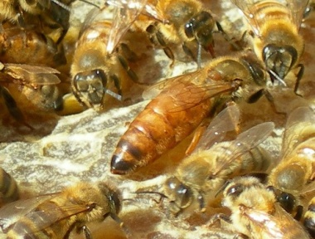
- In a bee colony there is always only one queen bee. She is the boss!
- The queen is a bit bigger than the other bees.
- She does not have pollen baskets on her legs as her only job is to lay eggs.
- She can lay 2000 eggs a day!

5. What is a male drone bee?
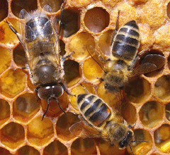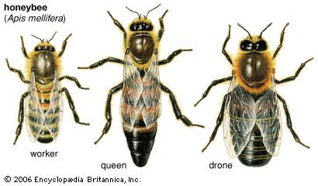
- The only job of the male drone bees is to help the queen bee make eggs to make new bees.
- When they have helped the queen, they die.
- The male drone bee has no stinger.
- They stay inside the hive all day and night.

6. What is a female worker bee?
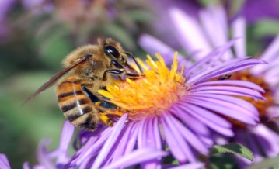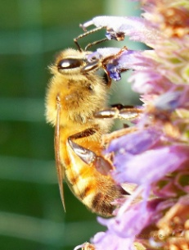
- Worker bees build and clean the hives and fly out to collect nectar and pollen.
- They have a long straw tongue to suck up the nectar in flowers.
- A worker bee needs to visit 4000 flowers to make 1 tablespoon of honey!
- Worker bees also protect their hive by stinging anything who comes close.

7. Who looks after honey bees?
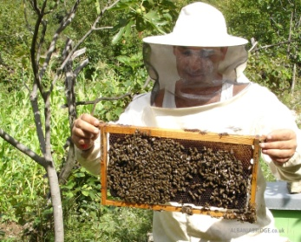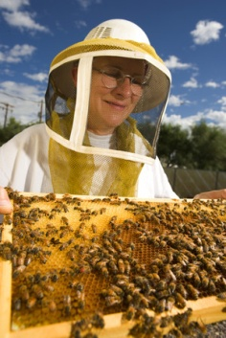
- People have kept bees for honey making for thousands of years.
- Bee keepers have to wear protective clothing so the bees don’t sting them.
- Bee keepers make hives for the bees out of straw, pottery or wooden boxes.
- Wild bees make their hives in hollow trees or logs.

8. What do honey bees do?
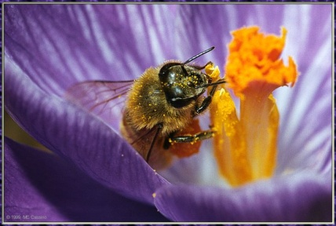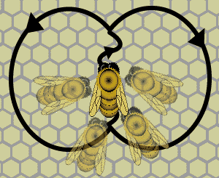
- Bees make honey from the nectar they collect from flowers.
- Honey bees like flowers with bright colours but they cannot see the colour red.
- Honey bees make the honey back in their hive.
- Honey bees do a little dance called the 'waggle dance' when they have found flowers to tell the other bees where the flowers are.
r

